CONFERENCE

End Ecocide Together:

From Theory to Practice

**18:00-18:10 Welcome speech: presentation of structure of the evening and introduction of the panel**

**18:10-19:30 A’ Panel**

Speakers:

1. Presentation of the End Ecocide Initiative, motivation and structure, its achievements, expectations for the future

**Valérie Cabanes (Member of the International Committee and Regional Coordinator, End Ecocide in Europe)**

1. Presentation of ecocide cases

**Pieter Jan Kerstens (Member of the National Belgian Team, End Ecocide in Europe)**

1. European Citizen´s Initiative-State of Play

**Assya Kavrakova (Program Manager ECSH, European Civil Society House)**

1. Assessment of ECIs’ contributions, Expectations for the future, your engagement and also your thoughts about Ecocide

**Maria Maggie Dokupilova (Secretary General of FYEG)**

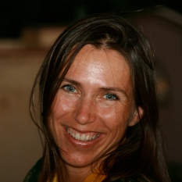**Valérie Cabanes** Mother of 2 amazing children already 21 and 14, lawyer in International Law and specialised in Human Rights. I spent 20 years working in Health and Human Rights projects overseas as a director of programmes for handicapped people, exploited women & children, street children, refugees. Since 2006, I focus my energy on indigenous people rights’ issues in Canada and Brazil. In the ECI team to promote Ecocide as a crime, I am the spokesperson to the media and at public events in Europe and I hope to raise our ecocide concerns and promote our initiative at a large scale. I am also the one who is coordinating the campaign in France.

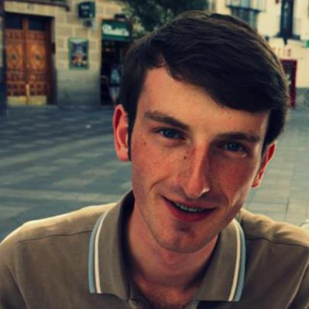

**Pieter Jan Kerstens** He recently graduated with a master’s degree in economics and will start a PhD at KULAK. He also holds degrees in mathematical engineering and computer science. During his studies in Leuven, he was part of the house of Ecoloco which organized events for the other students around the theme of sustainability. He joined "End Ecocide in Europe" in June 2013 and is active as an "Ecocide cases" writer and in the Belgium country team. He joined the initiative, because he strongly believes this initiative is one big step forward in trying to curb climate change.

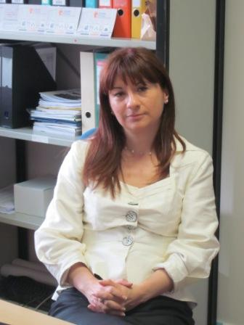

**Assya Kavrakova** is the Program Manager of the European Citizens' House at ECAS, Brussels. Within its framework she supervises the EU Rights Clinic and the European citizens' initiatives ECIs' support centre.

Before joining ECAS she served for 12 years (2000 – 2012) as the Director of the European Policies and Civic participation Program at the Open Society Institute – Sofia. She was also leading the analytical and research activity of the European Policies Initiative at the OSI – Sofia and she has personally authored the paper "The Unfinished Business of the Fifth Enlargement Countries". She has a Master's degree in Law and a Master's degree in European integration from St. Kliment Ohridski University of Sofia. She has worked as Public Policies and Outreach Director at the Democracy Network Program (DemNet) of the United States Agency for International Development.

She was also the Executive Director of Transparency without Borders Association, the national branch office of Transparency International. Assya Kavrakova is a Fellow of German Marshall Memorial Fellowship, USA and a Fellow of the International Fellowship Programme, Brussels. She is the author of the Bulgarian chapter of the reports "TV across Europe: Regulation, Policy, Independence 2005" and "TV across Europe: Follow-up reports 2008" –of the OSI EU Monitoring and Advocacy Program, publications available at [www.mediapolicy.org](http://www.mediapolicy.org)

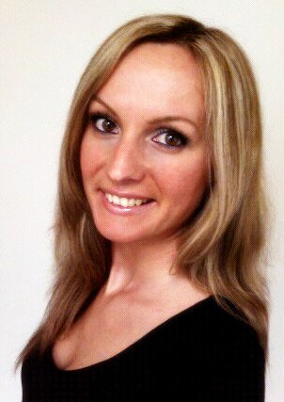**Maria Maggie Dokupilova** is the Secretary General of the Federation of Young European Greens. Before she started this mandate, she was a member of the Executive Committee for 3 years and was involved in young green organizations, being also the Secretary General of Youth and Environment Europe and an active member of Scouts in Slovakia, where she comes from. She studied international relations and is also the Board member of the European Youth Forum.

**19:30-20:00 Public Debate & Networking Activity**

* Photo exposition of Good Planet Belgium: a serie of 20 photos with water theme.
* Networking activity during which snacks and homemade food[1] will be available

**20:00-20:10 Introduction of the second panel**

**20:10-21:15 B’ Panel**

**Theme: working together**

Present their particular role in the defence of nature and the potential common paths with the End Ecocide in Europe initiative

1. The Corporation Project: Maximizing shareholder value and environmental sustainability

**Chris Halburd (ELS & ECCJ)**

1. Position paper on the future of SDGs from Eastern Europe, Caucasus and Central Asia (EECCA)

**Leida Rijnhout (ANPED)**

1. How ill environment means ill people

**Olga Rostkowa (President EMSA)**

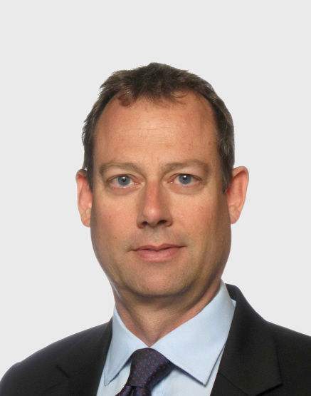

**Christopher Halburd – ELS (Environmental Law System)/ ECCJ (European Coalition for Corporate Justice)**

Chris is a solicitor (Australian), former mediator, arbitrator, company secretary and board director. He is presently Head of Brussels Operations for the Environmental Law Service (ELS). ELS is a public interest law firm established in 1995 with offices in the Czech Republic, Poland and here in Brussels. ELS is part of the steering group for the European Coalition for Corporate Justice (ECCJ).

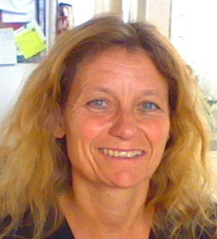**Leida Rijnhout - ANPED (Northern Alliance for Sustainability)**

Leida Rijnhout has a background in cultural anthropology with many years of experience in international development cooperation, including field work in Bolivia. She has been the coordinator of the Flemish Platform on Sustainable Development (VODO). As head of this platform, she worked on several issues within the framework of Sustainable Development: Agriculture, Climate, Local Agenda 21, SCP, ecological footprint, etc. Since 2009, she is the executive director of ANPED (Northern Alliance for Sustainability), an international network on sustainable development that is integrating the so-called “strong sustainability” approach in its activities on the different policy levels (UN, OECD, EC). For many years, she coordinated the activities of an international working group, which was part of an international think tank (ALOE) on ”ecological debt and environmental justice”. Her current activities relate to the themes of ecological economics, sustainable economy, sustainable consumption and production (SCP) and resource justice.

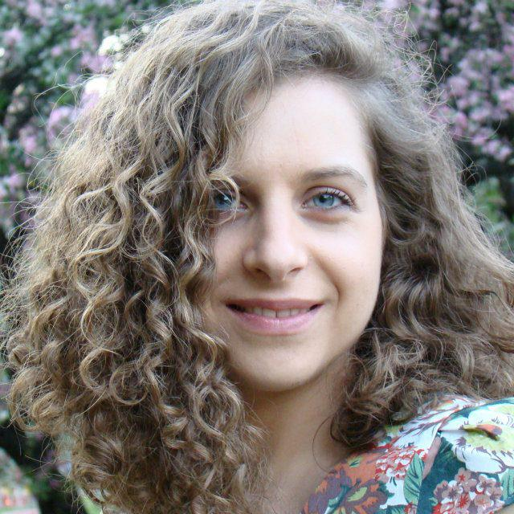**Olga Rostkowska** – a final-year medical student at the Medical University of Warsaw in Poland. President of the European Medical Students’ Association (EMSA) and an intern at the Standing Committee of European Doctors (CPME) office in Brussels. She has particular interest in the public health issues on the European level with special focus on the ageing populations (how to get old properly?). Editor-in-chief of the magazine EuroMeds of which main content are articles prepared by health-care students sharing ideas about projects and activities in their academic life (oscillating around medicine and various topics in public health). She is a hired translator working in Polish, English and Italian on materials related to health-care. Active trainer in soft skills for the Youth NGOs since 2011. Vegetarian

.

**21:15-21:35 Music concert with Giannis Efstathopoulos**

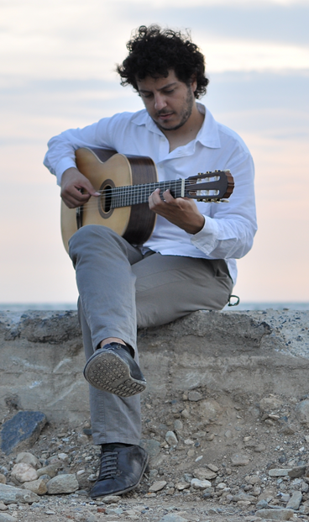 **Yiannis Efstathopoulos** -Graduate with the highest distinction of the University of Macedonia-Department of Music Science and Arts under the supervision of Elena Papandreou and holder of ‘’Solist Diploma’’ in January of 2010 from the class of Thanos Mitsalas at the State Conservatory of Thessaloniki. The same year, he attended guitar lessons with Oscar Ghiglia in Accademia Chigiana in Siena of Italy, getting ‘’Diploma Di Merito’’ and a scholarship.

He has participated in guitar master classes with famous guitarists like Roberto Aussel, Thomas Muller-Pering, Odair Assad, Ricardo Gallen, Zoran Dukic, Margarita Escarpa, Sharon Isbin and recently was among the finalists of the 11th Veria International Guitar Competition taking 2nd distinction. Yiannis played a lot of concerts in his country, recitals or chamber’s music concerts and collaborated as a soloist with the Sympony Orchestra of the University of Macedonia in Megaron Concert Hall of Thessaloniki. Now, he lives in Brussels, he finished his Master degree with Magna Cum Laude and continues in the Postgraduate program under the guidance of Antigoni Goni in the Koninklijk Conservatorium. Moreover holds Diplomas in Harmony and Counterpoint and is interested in Early Music studying renaissance lute with Dirk De Hertog

**22:00 End of the Conference**

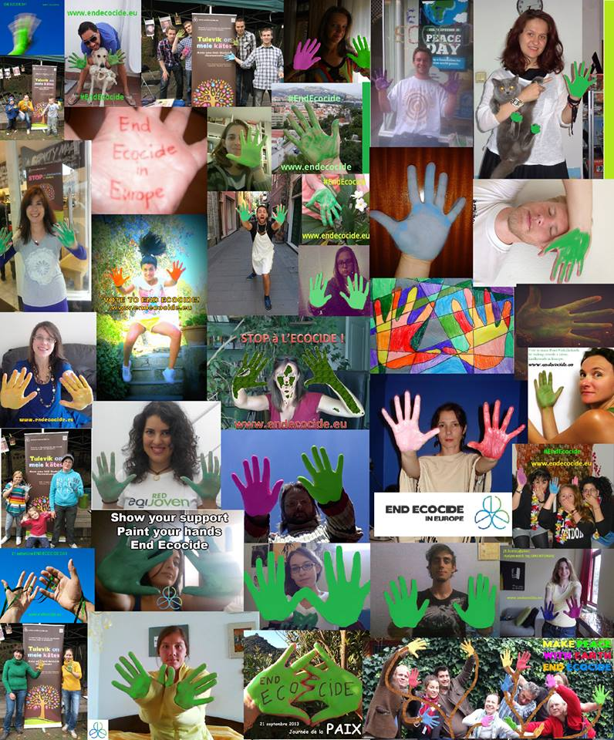

1. All products are bio